Staff Report
Meeting Date: July 11, 2023
To: Siskiyou County Board of Supervisors
From: Bernadette Cizin, Assistant Planner
Subject: Proposed Fiock Agricultural Preserve Amendment, Williamson Act Rescission with Re-entry, Agricultural Preserve Amendment (APA-23-06) and CEQA Determination

Background and Discussion
On May 11, 2023, the County received an application for a Williamson Act Contract amendment which proposes to exchange, through boundary line adjustment, approximately 1.5 acres of land between Williamson Act Contract encumbered and non-encumbered parcels (Figure 1). This project is being proposed due to the construction of a small communications facility on the non-encumbered property (Lopez), which was intended to be constructed on the encumbered property (Fiock).
In order to complete the boundary line adjustment, we must first address the Agricultural Preserve boundary and Williamson Act Contract by amending them to reflect the proposed property boundary.
This project does not propose to increase or decrease the acreage of the existing agricultural preserve but to exchange approximately equal land from the preserve to the preserve.
Agricultural Preserve Administrator Review
Staff prepared a detailed report (Exhibit C) for review and recommendation by the Agricultural Preserve Administrator. Based on the report, the Administrator found the applicant’s request is consistent with the County Rules for the Establishment and Administration of Agricultural Preserves and Williamson Act Contracts and recommends the Board rescind and reissue the contract as proposed and amend the existing preserve to remove the subject property and establish a new agricultural preserve.

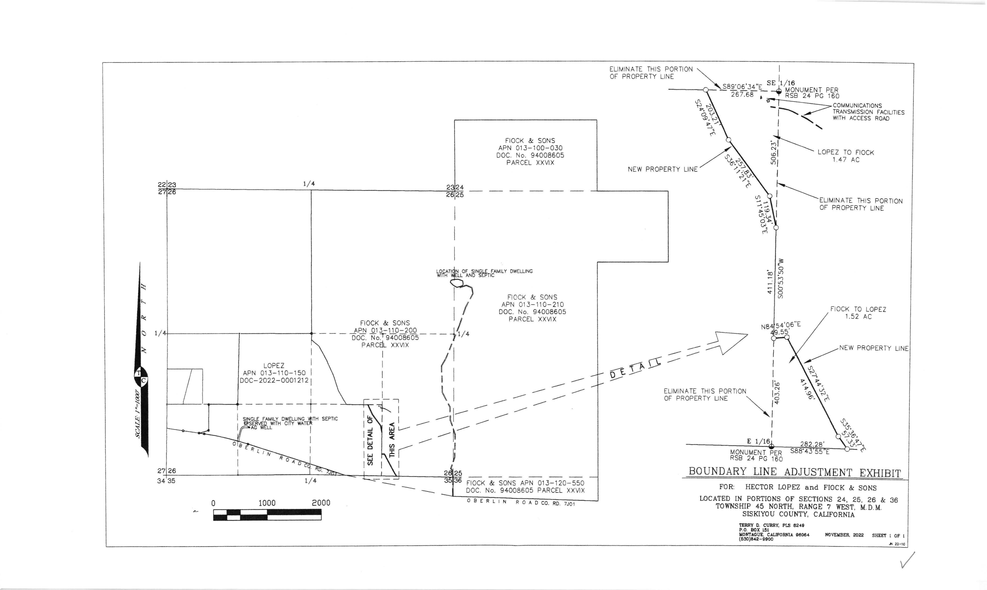
Figure 1: Subject Parcels

Environmental Review
Staff is proposing that the proposed project be considered categorically exempt from the California Environmental Quality Act (CEQA) pursuant to CEQA Guidelines Section 15317, Open Space Easements or Contracts. A Categorical Exemption implies that the project will not result in any significant adverse environmental effects. CEQA Guidelines Section 15317 specifically exempts the making and renewing of open space contracts under the Williamson Act, which is applicable to the subject action.
The Board of Supervisors must consider the proposed CEQA exemption together with any comments received during the public review process. Further, the exemption can only be approved if the Board finds, based on the whole record before it, that there is not substantial evidence that the project will have a significant effect on the environment. Accordingly, a finding to this effect has been incorporated into both draft resolutions prepared for the Board’s consideration.

Comments
Agency Comments
No Agency comments have been received as of the preparation of this staff report.
Public Comments
Notice of the project was published and posted as required prior to the Board of Supervisors meeting and no public comment was received as of the preparation of this staff report.

Recommended Action
Should the Board of Supervisors concur with staff’s analysis, staff recommends that the Board of Supervisors find that the proposed modifications to the Williamson Act contract and Agricultural Preserve are exempt from CEQA and approve said modifications.
A draft motion to this effect is provided below.

Recommended Motions
I move to take the following actions:
- Determine the project exempt from CEQA in accordance with Section 15317, Open Space Easements or Contracts; and
- Adopt the attached resolution approving amendment to the existing Agricultural Preserve and establishment of a new preserve; and
- Adopt the attached resolution approving the rescission and reentry of the applicable Williamson Act contract; and

Exhibits to the Staff Report
- Draft Resolution amending the existing Agricultural Preserve and establishing a new preserve
- Draft Resolution Approving the Rescission of the subject property from the existing contracts and Reentry into a new Williamson Act Contract
- Exhibit A within Draft Resolution: Williamson Act Contract – Draft
- Agricultural Preserve Administrator Staff Report with Recommendation

